Environmental Management Systems (EMS)
Fact Sheets
For My EMS Workbook

For My EMS Workbook

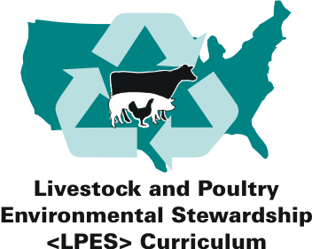

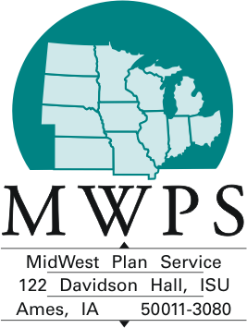

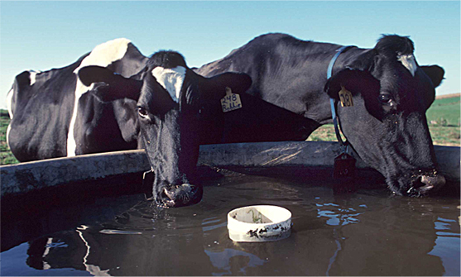
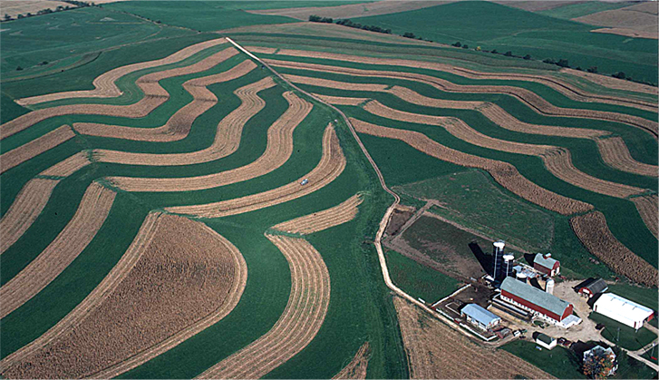
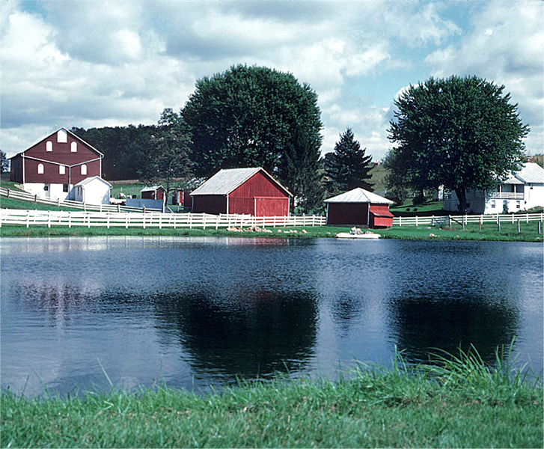
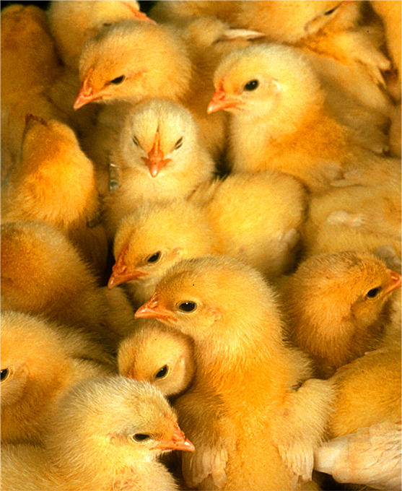

Developed by the Partners for Livestock EMS Project

Financial Support
This publication was produced as part of the "Partners for Livestock Environ-mental Management Systems" (EMS) Project. The project was funded by USDA-CSREES Initiative for Future Agriculture and Food Systems grant, award #00-52103-9650. Principal investigators for this project include Gary Jackson, University of Wisconsin, 608-265-2773; Rick Koelsch, University of Nebraska, 402-472-4051; Elizabeth Bird, now at Montana State University, 406-994-2520; Bill Bland, University of Wisconsin, 608-262-0221; and Mark Risse, University of Georgia, 706-542-9067.

Disclaimer
Any opinions, findings, conclusions, or recommendations expressed in this publication are those of the author(s) and do not necessarily reflect the view
of the U.S. Department of Agriculture.

Copyright © 2005 by MidWest Plan Service.
Iowa State University, Ames, Iowa 50011-3080.

For copyright permission, contact MidWest Plan Service (MWPS) at 515-294-4337. Organizations may reproduce the EMS products for non-commercial use, provided they acknowledge MWPS as the copyright owner and include the following credit statement:

Reprinted from Partners for Livestock Environmental Management Systems
EMS Fact Sheets, authored by Jill Heemstra and Rick Koelsch, University of Nebraska, courtesy of MidWest Plan Service, Iowa State University, Ames,
Iowa 50011-3080
Copyright © 2005.

Acknowledgments
The Partners for Livestock EMS team consists of representatives from Georgia, Idaho, Iowa, Montana, Nebraska, New York, North Carolina, Pennsylvania, Texas, Utah, Virginia, and Wisconsin. Individuals from these states were involved in the development, review, delivery, and update of the materials.
Over 200 producers also participated in this pilot project. For more information about the Partners Project and agriculture EMS, visit the website at http://www.uwex.edu/AgEMS or http://ems.unl.edu.

Contents Page

Table 1. Correlation between Livestock*A*Syst and EMS Products iv

Environmental Policy Statement 1
Fact Sheet 1. What Are My Significant Environmental Issues? 2
Fact Sheet 2. My Environmental Policy Statement 3

Plan 4
Fact Sheet 3. Communications 5
Fact Sheet 4. What Are My Priorities? 6
Fact Sheet 5. Which Risks Are Significant? 7
Fact Sheet 6. Stewardship Plan: Objectives and Performance Measures 8

Implement 10
Fact Sheet 7. Communication and Training 11
Fact Sheet 8. Keeping Track of It All 12
Fact Sheet 9. Do I Need to Standardize Procedures? 13
Fact Sheet 10. Am I Prepared for Emergencies? 14

Check and Correct 15
Fact Sheet 11a. Am I Identifying and Addressing Issues? 16
Fact Sheet 11b. Did I Do What I Planned? 17

Review and Improve 18
Fact Sheet 12. Management Review: Where Do I Go From Here? 19

Table 1. Correlation between Livestock*A*Syst, EMS Fact Sheets for My EMS Workbook, My EMS Workbook, and EMS Supplement Handouts for EMS Educators and Coaches.

Livestock*A*Syst | EMS Fact Sheets | My EMS Workbook | Supplemental Handouts
Environmental Policy Statement
Livestock System Improvement Plan  (pages 2-3, 40) | Fact Sheet 1. What Are My Significant Environmental Issues? | Work Sheet 1. Significant Environmental Issues | Handout 1. ID of Significant Environmental Issues
Not part of Livestock*A*Syst | Fact Sheet 2. My Environmental Policy Statement | Work Sheet 2. My Environmental Policy Statement | Handout 2a. Example Stewardship Commitments  Handout 2b. Example Policy Statements  Handout 2c. Draft Environmental Policy Statement
Plan
Not part of Livestock*A*Syst | Fact Sheet 3. Communication | Work Sheet 3. Communication | Handout 3. External Communication Ideas
Livestock System Improvement Plan  (pages 2-3, 40) | Fact Sheet 4. What Are My Priorities? | Work Sheet 4. What Are My Priorities? | Handout 4a. Environmental Regulations Affecting Animal Feeding Operations  Handout 4b. Do I Need an NPDES Permit?
Livestock System Improvement Plan  (pages 2-3, 40) | Fact Sheet 5. Which Risks Are Significant? | Work Sheet 5. Assessments Completed | Handout 5. Resources for Assessment
Livestock System Improvement Plan  (pages 2-3, 40) | Fact Sheet 6. Stewardship Plan: Objectives and Performance Measures | Work Sheet 6. Stewardship Plan for __________. | Handout 6. Resources for Technical Support of EMS
Implement
Not part of Livestock*A*Syst | Fact Sheet 7. Communication and Training | Work Sheet 7. Training Needs | Handout 7. Training Log
Livestock System Improvement Plan  (pages 2-3, 40) | Fact Sheet 8. Keeping Track of It All | Work Sheet 8a. Environmental Records  Work Sheet 8b. EMS Records | Handout 8. Stewardship Plan Fact Sheet
Not part of Livestock*A*Syst | Fact Sheet 9. Do I Need to Standardize Procedures? | Work Sheet 9. Standard Operating Procedures (SOPs) | Handout 9. Sample SOP
Emergency Plan and Employee Training (page 35) | Fact Sheet 10. Am I Prepared for Emergencies? | Work Sheet 10. Emergency Response Plans (ERPs) | Handout 10. ERP Template
Check and Correct
Not part of Livestock*A*Syst | Fact Sheet 11a. Am I Identifying and Addressing Issues? | --- | ---
Not part of Livestock*A*Syst | Fact Sheet 11b. Did I Do What I Planned? | Work Sheet 11. Audits | Work Sheet 11a. Audit Checklist: Overall EMS  Work Sheet 11b. Audit Checklist: Stewardship Plans
Review and Improve
Not part of Livestock*A*Syst | Fact Sheet 12. Management Review: Where Do I Go From Here? | Work Sheet 12. Management Reviews | Handout 12a. Management Review Checklist: Overall EMS  Handout 12a. Management Review Checklist: Stewardship Plans

Environmental Policy Statement

Purpose

The environmental policy statement establishes the stewardship commitments important to you and others who live and work on a farm or ranch. It sets the direction for the environmental efforts of your livestock or poultry operation.
It is one of the first pieces of information you will share with farm staff and possibly community members because it defines the environmental stewardship principles important to your animal feeding operation.

Environmental

Policy Statement

Plan

Implement

Check and Correct

Review and Improve

Outcomes
At the conclusion of this “Environmental Policy Statement” section, you will have:
- Identified and listed the environmental issues of greatest importance to your farm or ranch.
- Established an environmental policy statement that expresses the priorities and commitments you consider most critical to your livestock or poultry operation.

Fact Sheet 1. What Are My Significant Environmental Issues?
This step will help you deter-mine which issues are most significant to your operation.

Every operation faces a unique set of challenges and circumstances. This exercise will assist in evaluating a wide range of issues to identify those
that are currently important or those anticipated to become important in the future. The issues you select can be part of your policy statement and will be used to focus your stewardship plans toward efforts most likely to address those significant issues.

Which Issues Do I Need to Address At This Time?
"Handout 1. Identification of Significant Environmental Issues” contains a wide range of environmental issues to evaluate. It asks you to consider those issues from several different points of view. You are encouraged to change or add to the issues (or points of view) listed on Handout 1. Your knowledge of your own rural community, how likely it is that particular events could occur, and the severity if it did occur should be used when deciding which issues are important and which are not. For example, an owner whose operation borders a continuous stream containing an endangered fish species might regard surface water quality issues differently than one with no direct drainage to a stream.

Handout 1 asks you to consider the perspectives of neighbors, family, employees, or regulators. It also asks you to consider your own interests and vision for the future. The quality of life you and your family aspire to have can be a powerful influence on how you manage your resources. These and other long-term priorities should be factored into your EMS.
One of the most useful aspects of the EMS process for me turned out to be learning about how my neighbors view my farm. Knowing their perspectives helped me prioritize what
to tackle first to address their and my own environmental concerns.
---Wisconsin dairy producer

There are no hard and fast rules for selecting which issues are significant. Some people identify two or three significant issues while others identify a dozen. You can select issues with the most “Xs” or those that are especially sensitive to one group. Selecting an issue does not mean you must immediately implement an expensive or time-consuming solution. It does mean that you will evaluate your current activities in regard to that issue and decide if additional efforts are needed. In the future, you will re-evaluate your significant environmental issues on a regular basis to be sure your EMS continues to address those most vital to your operation.

Recommended Activities
1. Complete "Handout 1. Identification of Significant Environmental Issues."
2. Complete "Work Sheet 1. Significant Environmental Issues” in My EMS Workbook.

Identifying significant issues should not be a solo exercise. Family members, business partners, key employees, and other key personnel should be included in the discussion. Taking time to talk to (and listen to) suppliers, customers, neighbors, and others may also be beneficial.

Fact Sheet 2. My Environmental Policy Statement
This exercise will help you develop your environ-mental policy statement, the foundation of your EMS.

The environmental policy statement establishes the stewardship commit-ments important to you and others who live and work on the farm or ranch. It is one of the first pieces of information you will share with other people. Future activities will be evaluated by asking, "What does our policy statement say we will do?"

What Should My Policy Statement Include?
Your policy statement needs to include a brief description of your operation. It also needs to include commitments to regulatory compliance, pollution prevention, and continual improvement. While you could write a policy statement using generic statements like “We are committed to preventing pollution,” your policy will be more meaningful if you personalize it with statements such as this one developed by
a poultry producer:

“We are committed to preventing the discharge of pollutants into the soil, water, or air so that our children will be proud to inherit this land.”

Your policy statement should be a reflection of your unique beliefs and intentions. "Handout 2a. Example Stewardship Commitments” contains many examples you can use for ideas as you develop your own policy commitments. Review those examples and edit them or come up with your own unique commit-ments to include in your policy statement. Other key personnel, especially business partners, family, and key employees should be included and given opportunities for feedback.

The rest is up to you. Your policy may be long or short, but its basic purpose is to tell the reader what your operation is about and what you believe. It does not need to be specific, since it should continue to apply to your operation for many years. The policy statement should not include rigid or absolute terms such as “never,” “always,” and “eliminate” because these terms can make your policy commitments difficult or impossible to attain. For example, “Our farm is committed to eliminating odor nuisances experienced by our neighbors” is potentially impossible to achieve. A better statement might be “We are committed to reducing odor nuisances from our livestock operation.”
One producer put his policy on laminated wallet cards for all of his employees. He remarked that they never forgot their cards, and he frequently saw them reading the card
or discussing it with other employees. "They really appreciated the fact that I took the time to talk it over with them and explain why we were doing some of these things."

Recommended Activities
1. Develop your stewardship commitments using "Handout 2a. Example Stewardship Commitments.”
2. Write your draft policy statement on "Handout 2c. Draft Environmental Policy Statement.”
3. After getting input from other key personnel, write the finished environmental policy statement on Work Sheet 2 in My EMS Workbook.

Do not worry about making your policy statement perfect right now; many producers say that they review it and revise it several times during the development and implementation of their EMS.

Plan

Purpose
Many livestock and poultry producers already have environmental plans in place. The support provided to producers usually focuses on the technical issues and details involved in developing that plan. An EMS additionally focuses on the “process” steps to ensure implementation, maintenance, and improvement of
the plan. This workbook will assist you in applying the EMS process to existing technical plans as well as provide a framework for new plans you may develop. Figure 1 illustrates how an EMS can add pieces that are often missing from the puzzle (see items in italics).

Identify and control sources of error.
Develop Environmental Policy Statement and identify priorities.
CNMP

Manure Storage Plan
Emergency Plan

Existing Environmental
Permits and Plans
Odor
Plan
Nutrient Plan

Permits
Manure Marketing Plan

Monitor progress toward objectives.
Conserva-
tion Plan
Regularly improve plans.

Figure 1. The EMS puzzle. Many existing environmental plans require some additional “process” steps to ensure successful on-farm implementation of a plan.

Outcomes
At the conclusion of this “Plan” section, you will:
- Assign important communication-related tasks to key personnel in your operation.
- Summarize environmental efforts related to each of your significant issues and select those that are priorities.
- Conduct targeted environmental assessments of your operation.
- Develop at least one stewardship plan.

Fact Sheet 3. Communications
This exercise will help you set the stage for good communication during the entire EMS process.
Throughout the EMS process, you will be encouraged to talk with and seek input from family and employees as well as those external to your operation. Good communication can help manage the relationships among people within an operation (often listed as one of the most challenging aspects of farming or ranching). It can also help manage relationships with those outside of your operation (for example, regulators, neighbors, and customers).

How Can Communication Enhance My EMS Plan?
Taking time to talk (and listen) to others has many advantages when developing and implementing something as comprehensive as an EMS. Even a farm or ranch that is largely managed and operated by one person has a network (family, other producers, veterinarian, nutritionist, crop consultant, NRCS or other agencies, suppliers, integrator, and accountant) that can contribute ideas or better align their services or recommendations to help you reach your objectives. When co-workers, employees, or family have the opportunity for input and understand why you are undertaking this process, they are likely to have greater enthusiasm and buy-in for the plan.

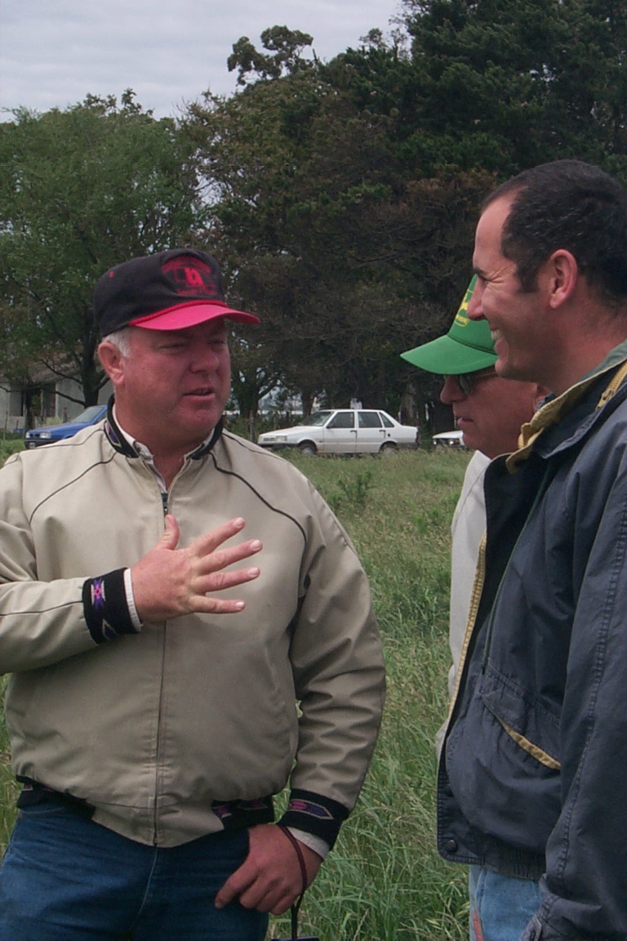How Can Communication Enhance My Business?
Not surprisingly, improved internal communication can be a way
to reduce the chances of human error within your system. Defining everyone’s roles, expectations, and responsibilities as well as how and why particular activities should be done reduces errors and improves employee decisions. Sometimes items that seem obvious or are part of the “common knowledge” of your operation are less clear than you previously believed.

Relationships with those outside of your operation (for example, neighbors, local community, and regulators) are becoming increasingly important. Fostering positive opinions toward your operation is possible even among those with a negative attitude toward your industry as a whole. Who will tell your story to these people? (They must be credible to that audience.) Where or how will you communicate? (Face-to-face communication is usually most effective.) What information do you want to convey? Do not let the urgency of your message overshadow the need to develop a relationship with that person. People are not likely to pay attention to your message until they have a chance to share their own concerns. (Your first job may be to listen!)

Recommended Activities
1. Complete "Handout 3. External Communication Ideas.”
2. Complete "Work Sheet 3. Communications” in My EMS Workbook.

Good communications within an operation and good relationships with those external to your operation do not happen overnight. You must decide it is important and continue to work at it. One producer said for the first two years he did not get any response to a newsletter he sent to his neighbors. He continued the effort and eventually began to receive feedback and comments from the neighbors who were more positive about his operation than before he distributed the newsletter.

Fact Sheet 4. What Are My Priorities?
This exercise will help you list current efforts to address your important environmental issues.
Most operations are not starting from scratch when they undertake an EMS. Many have gone through the permitting process or signed up for voluntary cost share or incentive programs related to environmental practices. Because of their legal implications, these existing plans or permits often represent priorities. Additional issues important to you, your family, or your business may also lead to priorities for your EMS.

What Regulatory Required Plans Do I Already Have?
If you have a permit(s), begin your evaluation by locating it and reviewing the plans that were developed as a condition of that permit(s). Common examples include nutrient management plan, conservation plan, manure storage plan, emergency response plan, or others. The existence of one or more written plans means you have already put a great deal of effort into the “Plan” portion of your EMS. In addition to permits, your operation may be subject to fuel storage, pesticide application, or other regulatory programs. To evaluate the status of your operation in relation to some of these programs, review "Handout 4. Environmental Regulations Affecting Animal Feeding Operations.”

What Voluntary Plans Do I Have?
As a result of the EMS efforts in Georgia, producers involved
in our program saw the utility of their nutrient management plans. Many of them had been keeping records of soil tests, manure analysis, daily feed, mortality, and crop yields. For
the first time they were actually using them to monitor progress toward goals and continuous improvement. They
also began to understand their nutrient management plans,
and many either changed their management or their plans
to better reflect the actual operation of their farms.
---Dr. Mark Risse, University of Georgia
Many incentive or cost-share programs are available to producers. You may have developed a conservation plan or another plan as part of EQIP (Environmental Quality Incentives Program), CRP (Conservation Reserve Program), a buffer strip program, or others. Some operations have chosen to strive for a particular certification (certified organic or others) or other structured programs (XYZ Natural Beef or similar examples). These existing efforts may already address or at least partially address one or more of your significant environmental issues.

Assessment and Other Proactive Efforts
You may have already identified some efforts or improvements that need to be made to address one or more of the significant environmental issues. (For example, you may have started rotational grazing or converting to no-till). The assessment process (next exercise) may also highlight items that can be added to Work Sheet 4 in My EMS Workbook.

Recommended Activities
- Complete "Handout 4. Environmental Regulations Affecting Animal Feeding Operations."
- Complete "Work Sheet 4. What Are My Priorities?"
- After completing Work Sheet 4, select at least one priority from that work sheet and continue through the rest of the workbook. Afterwards, you can always return to this step, select another, and work through the process until all of your priorities have been addressed.

It is not necessary to develop all priorities at once. The EMS process encourages you to prioritize and address the most critical items first.

Fact Sheet 5. Which Risks Are Significant?
This exercise will help you identify signif-icant risks related to your selected priority.

This exercise will build on the priority(ies) you previously identified in Work Sheet 4. Assessing related farm or ranch activities for significant potential (or real) environmental risks can help pinpoint potential improve-ments, control points, and practices that should continue in order to maintain good performance. Limited resources, especially time and money, suggest the importance of targeting your plans toward actions most likely
to return the greatest benefit from your investment.

How Could My Operation Affect This Issue?
Your most important resource is your knowledge of the system and how it fits together. You and your
key personnel should review the activities related to the priority being considered. For example, if you selected your nutrient management plan, you may need to assess the animal nutrition program, manure storage, and land application of manure as related activities.

Which of These Risks is Significant?
Some of the questions to consider in this process include:
- Where is current performance or the current situation unacceptable? (Our existing efforts and planning have not adequately managed this risk.)
- Where are the inefficiencies or opportunities to streamline the system?
- What risks occur if current controls fail or are not applied correctly? (What things are we doing well but need to continue to do well to minimize risks?)

Many options are available for completing an assessment. One is to assemble farm staff, walk through the operation, and discuss the activities that could lead to environmental concern. Better yet, involve an outside party that the farm staff trusts
in this review (for example, NRCS advisor, crop consultant, extension agent, industry or commodity group representative). Handout 5 contains a list of written assessment resources, although many others are available. Tools specific to your production system or geographical location are sometimes available from a commodity group, Cooperative Extension service, regulatory agency, or other groups. Your stewardship plan (next exercise) should consider how to manage risks identified in this assessment process.
This program has totally changed the way we think about environmental stewardship. Instead of waiting for DNR to force us to make changes after a problem, we work to identify priorities within a budget and proactively begin to address these needs in an orderly fashion, always focusing on the greatest environmental bang for the buck and always making improvements month to month.
---Iowa Beef Producer

Recommended Activities
- Review "Handout 5. Resources for Assessments.”
- Select and complete an assessment for your operation. At a minimum, your assessment should cover the priority(ies) you selected for further development from Work Sheet 4.
- Log the completed assessment on "Work Sheet 5. Assessments Completed” in My EMS Workbook.

If you identify a high-risk situation in your assessment, do not allow the desire to “fix it” to distract you from completing the entire assessment. After all, you can evaluate if it changes your priorities (Work Sheet 4) and then develop your stewardship plan(s) accordingly (next exercise).

Fact Sheet 6. Stewardship Plan:
Objectives and Performance Measures
This exercise will help you set your environmental objectives and plan how you will reach them.

For your selected priority, what is the desired environmental and production outcome that you hope to achieve? A clear defined target
and plan to achieve the target that everyone can understand is critical to reaching a desired environmental outcome. The stewardship plan can be considered your “EMS Road Map” that will define your destination and become the basis by which you will judge your operation’s environmental performance and future direction.

What if I Already Have a Written Plan for This Priority?
Some environmental priorities are complex and require a written technical plan describing specific details and how they are to be implemented. Often, regulated issues require these detailed planning procedures. A nutrient management plan is a common example. In such cases, you only need to summarize the important steps from the technical plan (on a copy of Work Sheet 6 in My EMS Workbook). Other stewardship plans may be very simple, and Work Sheet 6 can suffice as the entire written plan.

What Are the Objectives?
Your objectives need to be measurable. “Reducing nutrient losses” is admirable, but it should include
a measurable component such as “Within five years, we will reduce purchased fertilizer use by 50% through improved manure use.” Other examples with measurable components include “The Prime Rib Ranch will record where every load of manure is land applied in 2005.”

Some objectives will be easy to reach. Others may be more ambitious and remain a part of your plan for many years. Do not avoid setting an objective for a priority area because you do not currently have the time, money, or technology for a long-term solution. You can break it down into steps and define the pace at which those steps will progress.

What Needs to be Measured or Monitored to Determine Progress?
Performance measures are observations or measurements made at regular intervals. Their main purpose
is to help you track progress toward your objective and prompt action when performance is not within acceptable ranges. When selecting performance measures, consider the following:
- Why are we pursuing this objective? If you are implementing a rotational grazing system primarily to improve pasture productivity you may emphasize different measures than if you
are primarily trying to improve wildlife habitat.
- What measure(s) will be most useful to us? There is usually more than one possible performance measure for any given objective. You can measure pasture productivity directly by clipping vegetation. You can also indirectly measure it by tracking pounds of calf weaned per acre or “cow-days” (# of animals grazed multiplied by # of days) per acre.
- What is acceptable performance and what is not? Testing soil phosphorus may be a good performance measure, but it is meaningless unless you specify “good” and “bad” that triggers some type of action such as, “We will maintain soil P below 100 ppm or end manure application until soil P levels are below 100 ppm.”

Sometimes baseline measurements of your performance measures need to be taken before you can set objectives. For example, you need to know how much water you use before you can set the objective

of “Reduce water use by 10%.” Potential performance measures for a wide range of issues are listed
on "Handout 8. Stewardship Plan Fact Sheet.”

System Performance Measures
Many performance measures focus on a single activity or narrowly defined environmental issue. It
can also be valuable to measure the overall environmental performance of your system. One tool for measuring overall nutrient performance is the Whole Farm Nutrient Balance (WFNB). A WFNB compares the quantity of nutrients arriving on a farm from all sources (animals, feed, fertilizer, legumes) with the nutrient outputs (crops or animals sold or manure exported). An imbalance provides a system-wide picture of a farm’s environmental risk.

If nutrient management is a critical aspect of a farm’s environmental planning efforts, then a WFNB should be considered as one measurement option for defining a farm’s overall performance. Additional background information can be found at the following website:
Imbalance (losses to environment or
additions to soil storage)
Inputs
Managed
Outputs
Manure
Crops
Animals
Animals
Fertilizer
Feed
Legumes
Irrigation
https://lpelc.org/whole-farm-nutrient-balance/#:~:text=What%20is%20Whole%20Farm%20Nutrient,and%20off%20the%20entire%20farm.

Figure 3. Whole farm nutrient balance.

What Will Be Done?
Many plans will consist of one or more steps or targets to achieve in meeting your objective. They may be simple or complex, short- or long-term plans. If you have an existing plan, summarize the actions in this section. If this is a new plan or you are expanding on an existing plan, list the proposed actions. If you are uncertain about actions to take, it is better to list “Attend meetings and find information about irrigation scheduling” than to write nothing on your plan.

Recommended Activities
- Review "Handout 6. Resources for Technical Support of EMS” and "Handout 8. Stewardship Plan Fact Sheet” for potential performance measures.
- Complete a copy of "Work Sheet 6. Stewardship Plan for ____” for at least one priority selected from Work Sheet 4. The rate at which you develop each of your priorities into a stewardship plan will depend on the urgency of the priority and your time/resources.

Implement

Purpose
After developing a plan, it is time to go out and make it happen! This section of the workbook will focus on the processes that must be initiated to ensure everyone knows what they are expected to do, when to do it, and how to do it, guaranteeing that it gets done right.

Plan

Review and Improve

Environmental Policy Statement

Implement

Check and Correct

Outcomes
At the conclusion of this “Implement” section, you will:
- Identify the actions in your stewardship plans that are critical (most environmentally sensitive or carry the greatest legal liabilities).
- Decide how to avoid or control potential errors as these activities are completed.

Fact Sheet 7. Communication and Training
This exercise focuses on identifying communication and training needs for your stewardship plan.

Even great plans will gather dust if no one knows what to do or how to do it. Good communication ensures that the plan is implemented correctly and also gives others the chance to offer feedback, which is especially helpful when you review and make improvements to the plan. Another, increasingly important aspect of communication is working with those outside your operation (external communication). How you respond to complaints and requests as well as how actively you promote your operation’s stewardship efforts will affect community perception of your operation.

What Needs to Be Communicated?
On "Work Sheet 6. Stewardship Plan for ___," you assigned responsibilities for each of the major activities (steps) in your plan. Assigning responsibility on paper is one thing, but actual implementation begins when you:
- Make sure everyone is aware of his or her responsibilities.
- Evaluate if everyone has the resources, skills, and knowledge to competently carry out their responsibilities.
- Explain the environmental consequences of poor performance (Why is it important to do this task well?) and benefits of good performance.
- Encourage questions, feedback, and suggestions for improvement.

This process can be very simple for a small operation where one person is responsible for most activities. It will require more time and effort for an operation with many employees or where language barriers exist.

What Training Is Needed?
On Work Sheet 7 in My EMS Workbook, you will create a training “to-do” list for farm or ranch staff that is relevant to their responsibilities. That work sheet can address on-farm training by the farm manager on activities such as standard operating procedures, record keeping, and emergency response plans. It may also address the need for off-farm educational opportunities, some of which may be mandatory for main-taining compliance with regulations. Updates on regulations, workshops on nutrient planning, or pesticide certification are examples of off-farm educational programs of value to some farm or ranch employees (or managers). Contact your local Cooperative Extension service, commodity groups, or local community/-technical colleges for opportunities or resources related to your training needs.

Recommended Activities
- Complete "Work Sheet 7. Training Needs” in My EMS Workbook.
- Review "Handout 7. Training Log” (optional) and evaluate if tracking completed training will assist you in meeting requirements of regulatory programs or will otherwise be useful in the management
of your operation. If so, incorporate the training log into My EMS Workbook or create a file/notebook to keep that information.

It is not necessary to obtain training for every activity at once. Identify the activities or actions in your stewardship plan(s) related to the greatest environmental risks or legal liability. Will improved training and/or communication reduce the potential for errors? After evaluating the success of these efforts, you can decide if additional activities will also benefit from training.

Fact Sheet 8. Keeping Track Of It All
This exercise will help you determine the best way to establish your environmental record-keeping system.
If you ask farmers or ranchers about tasks they dislike, record keeping is usually high on the list. However, the reality of farming and ranching in
the 21st century is that shrinking margins require sophisticated knowledge
of your system and interactions between system components. Increasing regulations and a demanding public means greater scrutiny of many of
your practices. Accurate and organized records will help you document compliance with regulations, track progress toward achieving your objectives, and identify improvements.

What Do I Need for Environmental Records?
Specific record-keeping needs can be identified by asking the following questions:
  - What records are required by regulation? Legal liability alone indicates that these items
should be carefully monitored and records retained for the specified period of time.
  - What equipment or structure failures could lead to environmental damage, health or safety concerns, legal liability, or expensive cleanup and repairs? Consider developing inspection checklists (for example, an inspection checklist for manure storage) and/or maintenance logs
(for example, maintenance log for manure pump/transfer lines) for these items. Records on the calibration of monitoring or application equipment (for example, calibrating manure spreaders) may also be needed to ensure critical calculations are made with accurate data.
  - What information will be important to track the performance measures or to complete the steps listed in your stewardship plan? In some cases, it can be important to record when certain activities or events occur (for example, record dates and amounts of manure application).
  - What information is needed to make management decisions or track the efficiency and profit-ability of the operation? Crop yields can affect your fertilizer calculations for following years,
or meter readings can help you track water usage.

How Do I Protect My Valuable Data?
Good Records Do Not Mean Lots of Paper

Photographs—A picture can be worth a thousand words. Dated photos can be used for “before” and “after” comparisons or changes over time.
Calendar—Post a calendar in a handy spot and record information directly onto it.
Laptop computer or hand-held electronic organizer—These are getting more affordable and allow easy backup of data.
Backing up or protecting important data from loss can be critical when emergencies occur. A fire-proof safe to store paper or electronic copies of critical records is a wise investment. Alternatively, your copies or backups can be stored offsite at a location not likely to be affected by the same emergency (fire or catastrophic storm). A good rule of thumb is to scan, copy, or backup important records once a month.

Recommended Activities
- Review "Handout 8. Stewardship Plan Fact Sheet” for record-keeping suggestions.
- Complete "Work Sheet 8a. Environmental Records” and "Work Sheet 8b. EMS Records” in My EMS Workbook.
- Review the “Sample Record-Keeping Forms” packet for examples. (This packet should be available from the same person or location you obtained the rest of these materials).

Fact Sheet 9. Do I Need to Standardize
Procedures?
This exercise will help you identify controls needed for critical procedures and documents.

Communication and training go a long way toward implementing a stewardship plan. At times, there may need to be an additional measure
of control applied to critical procedures or activities. Every producer should evaluate whether the use of written standard operating procedures (SOPs) would help ensure performance for especially sensitive aspects of their operation. You may already have one or more SOPs for important activities on your farm or ranch.
If so, you do not need to rewrite or ignore them. They can be included just as easily as new SOPs.

Do I Need Written SOPs?
Standard operating procedures are written instructions for completing a particular activity. They can be developed for anything done on a regular basis but are especially important for taking samples, calibrating equipment, completing complicated inspections/maintenance, or anyplace the integrity of your product could be compromised. Non-critical, simple activities that are common knowledge do not require this formality, but you should consider developing a written SOP if:
- There could be serious environmental, legal, or safety consequences if the procedure is done incorrectly.
- A procedure is done infrequently, cannot be easily memorized, must be done the same way
each time, or may be done by several different people.
- Someone else may need to complete the task in the absence of the person (for example,
vacation, injury, illness) who usually completes that procedure.
- It would speed up orientation of newly hired employees or those who work on a seasonal
or infrequent basis.

Not all SOPs need to be as elaborate as the sample SOP on Handout 9. You can use an extension publication, copy an owner’s manual page, or take a series of photos showing the procedure. A good SOP needs to be understandable (if necessary, translated into another language). It should also be posted where it is needed and possibly laminated to keep it legible. A rule of thumb is that someone who has never been on your operation should be able to understand and follow the SOP and then correctly perform the task.

What If I Make Changes?
New equipment, plan improvements, or other details may require you to make changes to an SOP.
List a date and “Approved by ___” on all SOPs. By comparing the dates on each copy of an SOP
posted/given to employees to the master list/file copy, you can quickly determine if the most recent version is being used or if it is an older copy. Another item that is important to note about each SOP
is the location(s) where they are to be posted or who was given copies. It seems fairly simple now to remember where each one is, but in a few years, it will be more difficult to track down every copy when changes need to be made. This method of controlling documents can be used on the policy statement, record-keeping forms, or other important papers, if needed.

Recommended Activities
- Review "Handout 9. Sample SOP.”
- Decide which actions/activities on your stewardship plan(s) require an SOP.
- Complete "Work Sheet 9. Standard Operating Procedures (SOPs)” in My EMS Workbook.

Fact Sheet 10. Am I Prepared For
Emergencies?
This exercise will help you review existing ERPs and evaluate the need for additional plans.

Emergency response plans (ERPs) are a written set of instructions detailing the action to be taken in an emergency. Developing and communicating these plans is key to preventing or minimizing environmental damage, injuries, or losses. If an emergency does occur,
they also help you manage legal liability. Permitted livestock operations may have one or more ERPs in place but may not have reviewed or shared those plans recently. Non-permitted farms and ranches should also consider situations within their operation that might require an ERP.

Have the Existing Plans Been Adequately Communicated?
Great plans only work if everyone else knows that they exist, can find them, and can understand them. Valuable time is wasted if the information (for example, phone numbers) is outdated, equipment listed on the plan has been moved or replaced, or the plan cannot be located. Very often, the farm or ranch manager has all of these details committed to memory and could act quickly to mitigate the situation. Consider this, if you were unavailable, would others know what to do?

Do I Need Any New ERPs?

Situations That Might Require an ERP:
- Catastrophic events such as fires, storms, or power failures.
- Leak or break of manure storage, or failure of manure handling/transfer equipment.
- Death of large numbers of animals.
- Fuel, chemical, or large grain/feed spills or leaks.
- Worker overcome by gases in manure storage pit or silo.
In deciding whether a situation requires a written ERP, consider the following questions:
- Can the situation occur very quickly, without time to plan on the spot?
- Could we be subject to legal liability (fines or lawsuits) if the situation occurs?
- Will the situation lead to severe environmental, health/safety, or economic consequences if it is not prevented or quickly mitigated?

If the answer to any of these questions is “yes,” then you should consider developing ERPs. If you already have one or more plans, consider the following question as well. Do others (including new employees) know the location and understand the contents of existing ERPs? If not or if their response time would be slow, then you should consider conducting training sessions (or rehearsals, if appropriate) of these plans.

Additional Information
For more information about ERPs, review the Livestock and Poultry Environmental Stewardship (LPES) Curriculum, Lesson 50, at http://lpes.org/Lessons/Lesson50/50_Emergency.html.

Recommended Activities
- Review "Handout 10. Emergency Response Plan Template.”
- Complete "Work Sheet 10. Emergency Response Plans (ERPs)” in My EMS Workbook.

Check and Correct

Purpose
Crop producers do not walk away from their newly planted crop until harvest. They monitor weeds, insects, and fertility to avoid situations that could damage yields. The same goes for your EMS. You defined your destination (“Plan” phase) and began working toward that objective (“Implement” phase). In the “Check and Correct” phase, you monitor the data that is collected, activities being completed, and try to identify and correct concerns as soon as possible.

Plan

Review and Improve

Environmental
Policy
Statement

Implement

Check and Correct

Outcomes
After completing the “Check and Correct” section, you will:
- Review problem-solving processes.
- Plan the details of your audit procedure.

Fact Sheet 11a. Am I Identifying and Addressing Issues?
This exercise will help you identify and correct issues, preventing recurrences.

In the “Plan” phase, you laid out a course of action. The “Implement” phase then focused on identifying the potential sources of errors and identifying ways to prevent those errors. Despite the best efforts, things never seem to go exactly as planned. This step asks you to consider how well your system is functioning in terms of noticing concerns, identifying the root cause, correcting the situation, and preventing recurrences. Producers with EMSs often comment that they spend less time “putting out fires” and more time managing their system.

Did I Catch the Issue Quickly?

An Ounce of Prevention . . .

One of the most common issues in a Wisconsin dairy pro-ducer’s system was pump failure. After taking some time to analyze why, he discovered that low oil levels were correlated with failures. By setting up a system where he monitored pump oil levels on a regular basis, the farmer greatly reduced failures, noting “I don’t get up in the middle of the night to fix pumps anymore!”
Some situations happen quick-ly, but many issues start small and get worse over time (for example, soil erosion, structural deterioration of a berm, excessive soil P levels). Are your performance measures, regular inspections, record keeping, and other activities helping you catch issues? If not, do you need to consider different measures, better employee training, and better communications. Do employees feel they have the authority to take action or do they know who to report issues to?

Did I Address the Root Cause?
Sometimes it is simple to identify and address the root cause (for example, forgetting to shut a valve),
and sometimes it is more difficult (for example, cause of poor crop yields). Identifying the true cause
of an issue is necessary before you can even begin to consider what changes should be made to prevent recurrences.

What Needs to Be Done to Prevent It From Recurring?
Identify changes that are needed. Then make these changes, and notify everyone affected by the change
as soon as possible. Employees who are accustomed to completing a procedure in a certain way may not notice an updated SOP unless you take the time to point out the changes to them. Ask yourself, "Can this same/similar issue occur somewhere else in the system?" If so, consider what can be done to prevent it.

Recommended Activities
No handouts or work sheets are associated with this fact sheet. If a serious situation occurs, such as
one with potential for future legal action, you should document the issue, cause(s), actions taken,
and results of those actions in a corrective action log/report.

The amount of effort involved in preventing and correcting issues should be appropriate to the [potential] seriousness of the issue. Minor issues do not need the same level of corrective/preventive effort as an issue that could/did lead to serious environmental damage, serious health or safety consequences, or noncompliance with regulations.

Fact Sheet 11b. Did I Do What I Planned?
This exercise will help you plan the details of your audit process.

From time to time, it is a good idea to ask, “Did I do what I planned?”
This audit gives you the chance to double check whether the plan has been implemented and maintained properly. It should also help you prepare for
an external audit by a certifying agency if you are seeking incentives or registration of your EMS.

What Is an Audit? What Am I Looking For?
Most good managers conduct mini-audits every day, but even so, some items are gradually discontinued or changes are made without all of the necessary follow-through. An audit involves several steps including making observations, talking with managers and employees, and reviewing records and documents to determine if the plan is being carried out and maintained.
- Verify the plan. Am I upholding the policy, meeting legal and voluntary obligations, and
making progress toward the objectives?
- Verify implementation. Does everyone know their responsibilities and how to do them well?
Are planned SOPs in place and being used? Are critical performance indicators and other information being recorded? Am I ready for emergencies?
- Verify check and correct. Are the anticipated inspections being completed? Are the appropriate records being maintained and used to identify potential concerns? When concerns are noted, are they addressed in a timely manner?

How Will I Set Up the Verification Process?
During the planning stages of your EMS (before you actually conduct your first audit), consider the following details:
- Who will do it? It can be extremely helpful to select a person(s) (for example, family member, another producer, extension agent) who was not involved in the development of your plan to conduct the audit. This step is especially important if you are seeking incentives or registration
of your EMS. Otherwise, the key personnel within the operation could work together to conduct the audit. (If done this way, it could possibly be done at the same time as the management review described in the next fact sheet).
- How often will it be done? These audits need to be done at least annually. They can be timed to occur after critical points in the production cycle (for example, planting, harvest, calving).
- What is our scope? You can audit the entire EMS at the same time, or you can break it down into pieces. For example, you could audit each stewardship plan separately, if it made sense to do so.

What Should I Do with the Results?
If a situation warrants immediate action, it should be taken. Otherwise, the results and recommendations from the audit will be used in "Fact Sheet 12. Management Review" (next exercise).

Recommended Activities
1. Complete "Work Sheet 11. Audit” in My EMS Workbook.
2. Review and file "Handouts 11a and b. Audit Checklist” for use when you conduct your audit.

The purpose of an audit is not to find faults. A good auditor tries to improve the system.

Review and Improve

Purpose
During the "Review and Improve" phase, you consider significant changes that have occurred within the operation or its operating climate. Those changes and your experiences with your EMS will dictate the need for updates or new steward-ship plans. The management review is the cornerstone of the commitment you made, in your environmental policy statement, to continual improvement. The management review will bring your EMS full circle because it will help you update your plan. This updated plan needs to be implemented, checked, and improved before it will once again be improved.

Plan

Review and Improve

Environmental Policy Statement

Implement

Check and Correct

Outcomes
After completing the “Review and Improve” section, you will plan the details
of your management review process and start a new cycle of “Plan-Implement-Check and Correct-Review and Improve.”

Fact Sheet 12. Management Review:
Where Do I Go From Here?

This exercise will help you plan your management review for continual improvement.

If you think of your EMS as a road map, then the management review involves looking it over to make sure you are headed in the right direction or to set a different destination. A management review requires you to evaluate past progress, current circumstances, and your vision for the future to ensure that your plan is still relevant.

Why Do I Need a Management Review?
If the world never changed, you could probably rely on the same plan forever. However, the real world changes on a daily basis, and you must anticipate and react to those changes to stay in business. As you reach objectives, your operation expands or diversifies, regulations change, or new issues become the “hot” topics. A management review will help you identify needed changes and ensures that your plan continues to focus your efforts on the most significant issues and risks.

How Do I Set Up the Management Review?
Once you begin your EMS process, it is a good idea to conduct your first management review within
a year, even if you have not fully implemented the plan. The review gives you the chance to scrutinize items that have been implemented and to ask “why” about items that have not been implemented. These reviews should continue on a regular basis (at least annually).
- When should the management review occur? If the same people will be involved in the audit (previous exercise) and the management review, the two processes could be done together. Otherwise, it should occur shortly after the audit.
- Who should conduct the management review? The top management of the farm or ranch and key personnel should all have input into the management review.
- How often will it be done? It should be done at least annually, although some businesses conduct them quarterly. An important change (for example, farm size or structure, regulations, turnover of key personnel) or other significant event can trigger a review.

What Should I Do with the Results?
A management review asks you to return to the beginning and edit the My EMS Workbook based on progress you have made (or not made) since it was developed or last updated. Once the plan is updated, the updates need to be implemented, subjected to the Check step, and included in future management reviews. An honest, realistic look at your operation and plan will provide a strong base for continued improvement of your environmental performance.

Recommended Activities
1. Fill out "Work Sheet 12. Management Reviews” in My EMS Workbook.
2. Review and file "Handout 12. Management Review Checklist” for use when you conduct a management review.

The EMS process does not require that you achieve perfect environmental performance but rather that you continue to identify ways to improve your environmental performance.

